הרצאה 1:

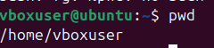

הרצאה 3:

Performed CRUD

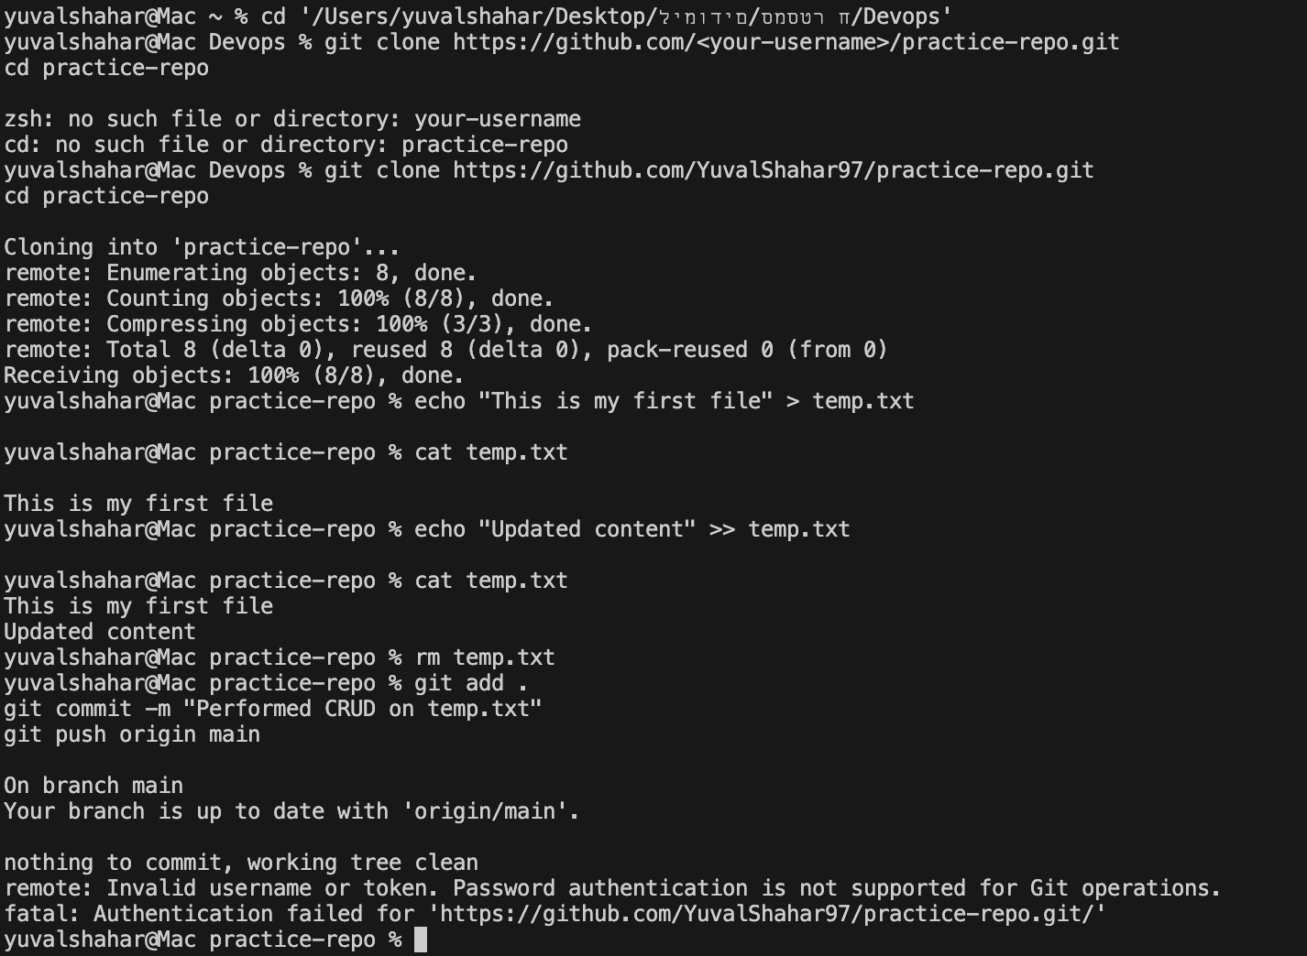

Dependabot is a GitHub tool that scans files containing dependencies (such as package.json, requirements.txt, etc.) and alerts you when there are new versions or security vulnerabilities.
It is used to keep your code up-to-date and secure.
Dependabot is especially important in projects that rely on external libraries.

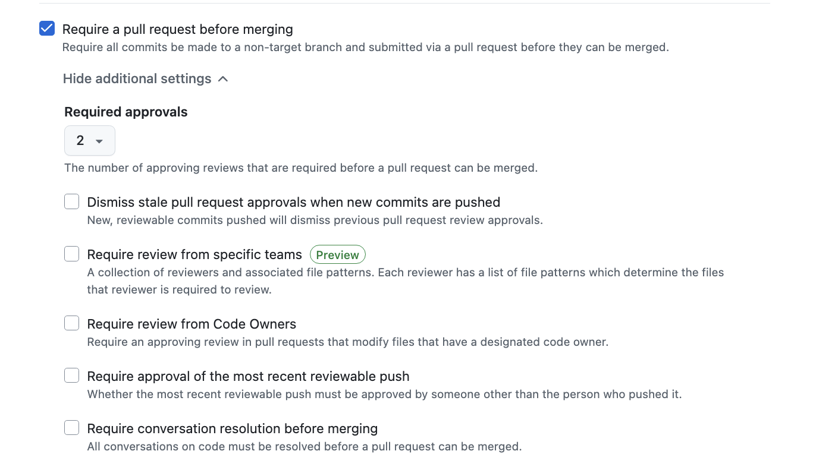
הרצאה 4:

